Welcome to my presentation on Dr Who

1. This is the Doctor 

- He is a Time Lord

- He has two Hearts 2 ♥

- He is 1000 years old

- He is from Gal-i-frey 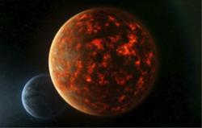

- He regenerates

- There have been 11 doctors 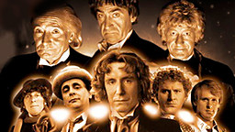

2. This is the TARDIS 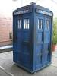

- It travels in Space and Time

- It is bigger inside than outside

Tardis means :

Time And Relative Dimensions in Space

- Friends

The doctor travels with friends

This is amy pond Clara is his latest friend


- This is a Sonic Screwdriver 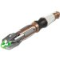
The doctor fights enemies with his sonic screwdriver
It opens doors and locks
Doesn’t work on wood
His Biggest Enemies are :
Cybermen 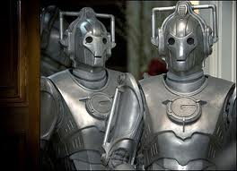
DALEKS 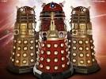
The Master 
- This is a cyberman
Have a human brain 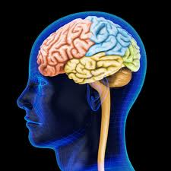
Turn people into robots 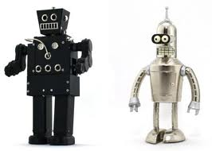

- DALEKS
- Created by Davros 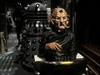
- From KALED people which is DALEK backwards
- Their home planet is Skaro

- Always saying EXTERMINATE !!

- This is the Master

He is a timelord as well

- Dalek SEC 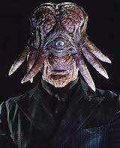
- leader of Daleks
- wanted to be more human
- killed by other Daleks
- Judoon 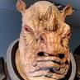
- Policemen of Universe 
10 Thankyou for listening

